**Title:** Climate Crisis or Just Passing Gas

**Team:** Conor, Courtney, Kate, Tyler

**Business Problem:** This project will review current climate related data and levels of pollutive gases and compare against potential contributors by state. The analysis hopes to identify drivers of higher unwanted gases and therefore dictate strategies to reduce levels

**Datasets:**

1. EPA – Emissions & Generation Resource Integrated Database (eGRID)
   1. <https://www.epa.gov/energy/emissions-generation-resource-integrated-database-egrid>

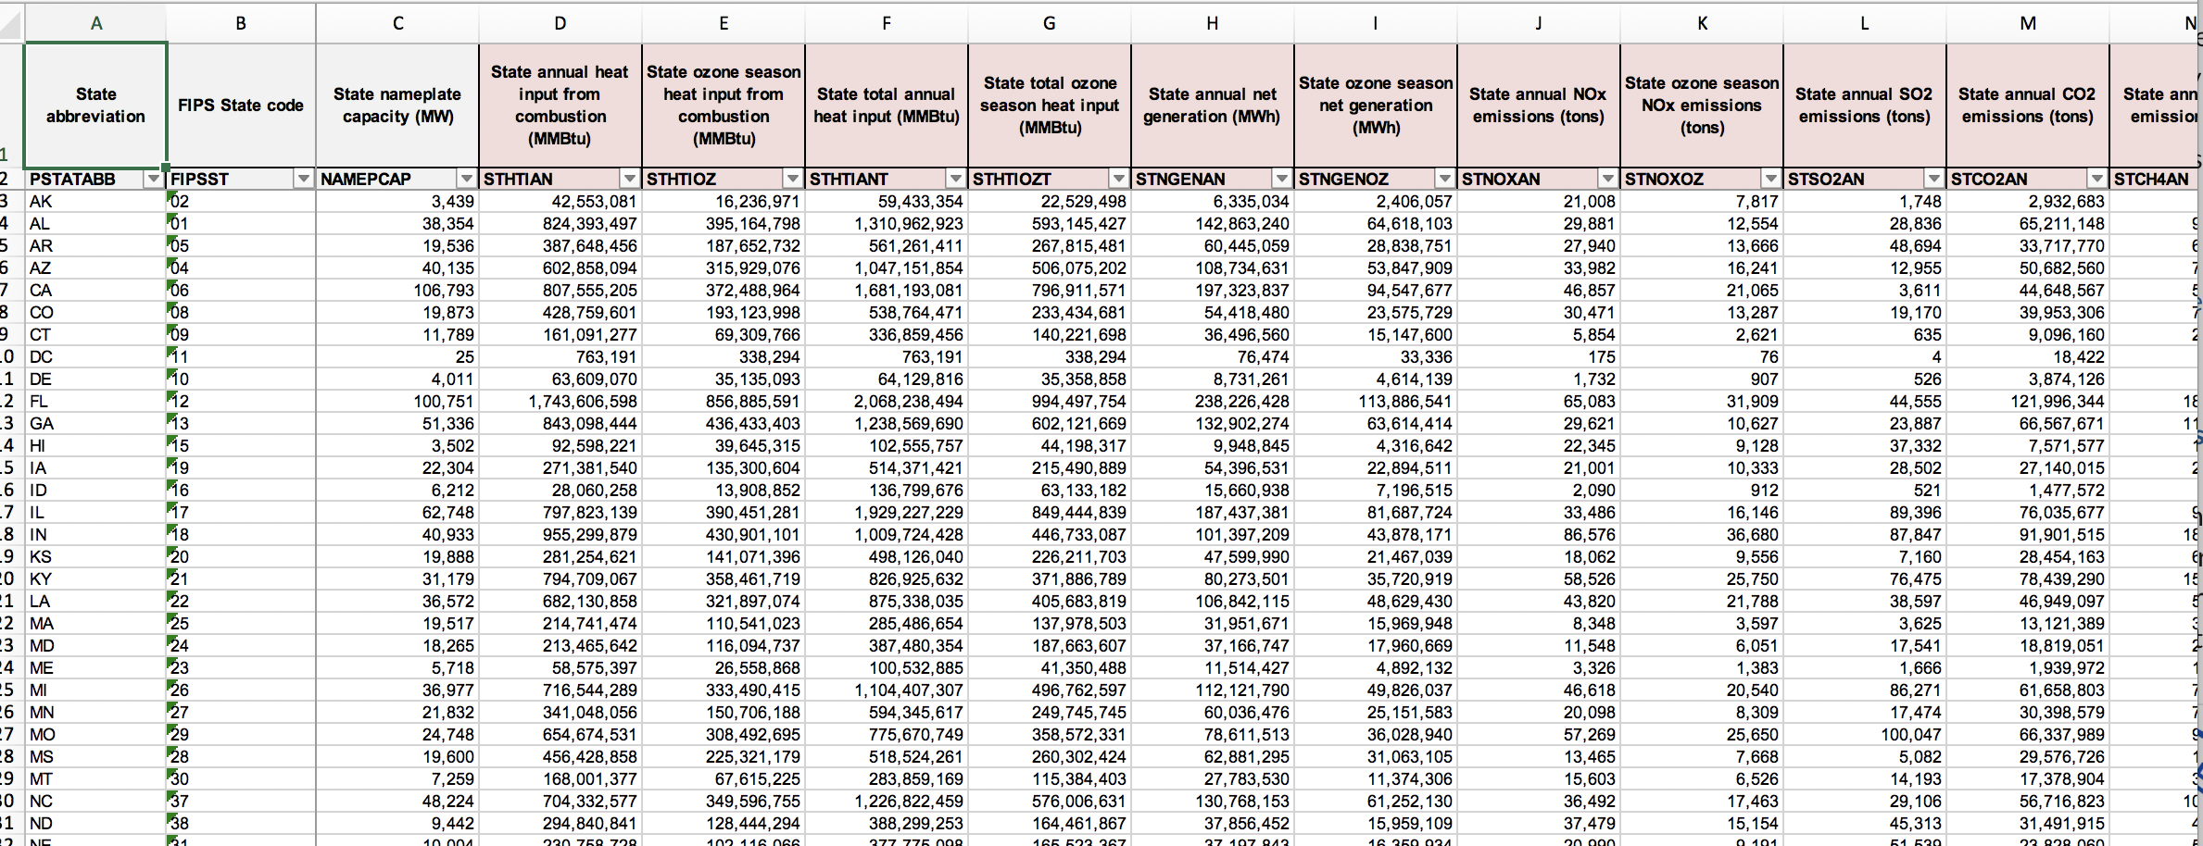

1. USDA Livestock Inventories by State
   1. <https://www.epa.gov/energy/emissions-generation-resource-integrated-database-egrid>



1. Methane production by each sector (Industrial, transportation, residential, energy, agriculture) from 1990-2009
2. Addl potential datasource: Number of cars per state, number of car sales per state, number of car registrations per state

**Database Used:** SQlite

**Project Track:** A custom "creative" D3.js project (i.e. non-standard graph or chart); In addition to Mapbox map of emissions vs contibutors

**Additional JS Libraries:** React library to allow users to quickly review specific data sets.